**EX.NO:7**

**Date:**

**IMPLEMENTATION OF SLR PARSER**

**AIM**

To implement slr parser using c program.

**ALGORITHM**

**STEP 1:** Get grammar as input from user in file.txt format.

**STEP 2:** Construct C = { I0, I1, ……. In}, the collection of sets of LR(0) items for G’.

**STEP 3:** State i is constructed from Ii. The parsing actions for state i are determined as follow :

* If [ A -> ?.a? ] is in Ii and GOTO(Ii , a) = Ij , then set ACTION[i, a] to “shift j”. Here a must be terminal.
* If [A -> ?.] is in Ii, then set ACTION[i, a] to “reduce A -> ?” for all a in FOLLOW(A); here Amay not be S’.
* Is [S -> S.] is in Ii, then set action[i, $] to “accept”. If any conflicting actions are generated bythe above rules we say that the grammar is not SLR.

**STEP 4**: The goto transitions for state i are constructed for all nonterminals   
 A using the rule:if GOTO( Ii , A ) = Ij then GOTO [i, A] = j.

**STEP 5:** All entries not defined by rules 2 and 3 are made error.

**PROGRAM**

#include<bits/stdc++.h>

#define error(x) cerr<<#x<<" = "<<x<<'\n' using namespace std;

set<char> ss; map<char,vector<vector<char>>> mp;

bool dfs(char i, char org, char last, map<char,vector<vector<char>>> &mp){

bool rtake = false; for(auto r : mp[i]){ bool take = true; for(auto s : r){

if(s == i) break; if(!take) break;

if(!(s>='A'&&s<='Z')&&s!='e'){ ss.insert(s);

break;

}

else if(s == 'e'){ if(org==i||i==last)  
ss.insert(s); rtake = true; break;

}

else{

take = dfs(s,org,r[r.size()-1],mp); rtake |= take;

}

}

}

return rtake;

}

map<int,map<char,set<pair<deque<char>,deque<char>>>>> f; map<int,vector<pair<int,char>>> g;

int num = -1;

void dfs2(char c, char way, int last, pair<deque<char>,deque<char>> curr){ map<char,set<pair<deque<char>,deque<char>>>> mp2; int rep = -2;

if(last != -1){

for(auto q : g[last]){ if(q.second == way){ rep = q.first;

mp2 = f[q.first];

}

}

}

mp2[c].insert(curr); int count = 10; while(count--){ for(auto q : mp2){ for(auto r : q.second){ if(!r.second.empty()){

if(r.second.front()>='A'&&r.second.front()<='Z'){ for(auto s : mp[r.second.front()]){ deque<char> st,emp;

for(auto t : s) st.push_back(t); mp2[r.second.front()].insert({emp,st});

}

}

}

}

}

}

for(auto q : f){ if(q.second == mp2){

g[last].push_back({q.first,way});

return;

}

}

if(rep == -2){ f[++num] = mp2; if(last != -1)

g[last].push_back({num,way}); }

else{

f[rep] = mp2;

}

int cc = num; for(auto q : mp2){

for(auto r : q.second){ if(!r.second.empty()){ r.first.push_back(r.second.front());

r.second.pop_front(); dfs2(q.first,r.first.back(),cc,r); }

}

}

}

int main(){ int i,j;

ifstream fin("inputslr.txt"); string num;

vector<int> fs; vector<vector<int>> a; char start;

bool flag = 0; cout<<"Grammar: "<<'\n'; while(getline(fin,num)){

if(flag == 0) start = num[0],flag = 1; cout<<num<<'\n';

vector<char> temp; char s = num[0];

for(i=3;i<num.size();i++){

if(num[i] == '|'){ mp[s].push_back(temp); temp.clear();

}

else temp.push_back(num[i]); }

mp[s].push_back(temp);

}

map<char,set<char>> fmp;  
for(auto q : mp){ ss.clear();

dfs(q.first,q.first,q.first,mp); for(auto g : ss) fmp[q.first].insert(g); }

cout<<'\n'; cout<<"FIRST: "<<'\n';

for(auto q : fmp){ string ans = ""; ans += q.first; ans += " = {";

for(char r : q.second){ ans += r;

ans += ',';

}

ans.pop_back(); ans+="}"; cout<<ans<<'\n';

}

map<char,set<char>> gmp; gmp[start].insert('$');

int count = 10; while(count--){ for(auto q : mp){ for(auto r : q.second){

for(i=0;i<r.size()-1;i++){

if(r[i]>='A'&&r[i]<='Z'){

if(!(r[i+1]>='A'&&r[i+1]<='Z')) gmp[r[i]].insert(r[i+1]); else {

char temp = r[i+1]; int j = i+1;

while(temp>='A'&&temp<='Z'){ if(*fmp[temp].begin()=='e'){ for(auto g : fmp[temp]){ if(g=='e') continue; gmp[r[i]].insert(g);

} j++;

if(j<r.size()){ temp = r[j];

if(!(temp>='A'&&temp<='Z')){ gmp[r[i]].insert(temp); break;

}

}

else{

for(auto g : gmp[q.first]) gmp[r[i]].insert(g); break;

}

}

else{

for(auto g : fmp[temp]){ gmp[r[i]].insert(g);

}

break;

}

}

}

}

}

if(r[r.size()-1]>='A'&&r[r.size()-1]<='Z'){

for(auto g : gmp[q.first]) gmp[r[i]].insert(g); }

}

}

}

cout<<'\n'; cout<<"FOLLOW: "<<'\n';

for(auto q : gmp){

string ans = ""; ans += q.first; ans += " = {";

for(char r : q.second){ ans += r;

ans += ',';

}

ans.pop_back(); ans+="}"; cout<<ans<<'\n';

}

string temp = ""; temp+='.'; temp+=start; deque<char> emp; deque<char> st; st.push_back(start);

dfs2('!','k',-1,{emp,st}); cout<<"\nProductions: "<<'\n'; int cc = 1;

set<char> action,go; map<pair<char,deque<char>>,int> pos; for(auto q :

mp){

go.insert(q.first); for(auto r : q.second){ cout<<"r"<<cc<<": "; string ans = "";

ans += q.first; ans+="->"; deque<char> temp;

for(auto s : r) ans += s,temp.push_back(s); pos[{q.first,temp}]

= cc;

for(auto s : r){

if(s>='A'&&s<='Z') go.insert(s); else action.insert(s);

}

cout<<ans<<'\n'; cc++;

}

}

cout<<"\nGraph: "<<'\n'; for(auto mp2 : f){ cout<<'\n';

cout<<"I"; cout<<mp2.first<<": \n";

for(auto q : mp2.second){ string ans

= "";

ans += q.first; ans += "->";

for(auto r : q.second){ for(auto t : r.first) ans+=t; ans+='.';

for(auto t : r.second) ans+=t; ans+='|';

}

ans.pop_back(); for(auto tt : ans){

if(tt == '!') cout<<start<<'\''; else cout<<tt;

}

cout<<'\n';

}

}

cout<<'\n'; cout<<"Edges: "<<'\n'; for(auto q : g){  
for(auto r : q.second){

cout<<"I"<<q.first<<" -> "<<r.second<<" -> "<<"I"<<r.first<<"\n"; }

}

action.insert('$'); cout<<"\nParsing Table:"<<'\n';

cout<<"St.\t\tAction & Goto"<<'\n'; int tot = f.size();

cout<<" \t";

for(auto q : action) cout<<q<<'\t'; for(auto q : go) cout<<q<<'\t'; cout<<'\n';

for(i=0;i<tot;i++){ cout<<"I"<<i<<'\t'; for(auto q : action){ if(g.count(i)){

int flag = 0; for(auto r : g[i]){ if(r.second == q){ flag = 1;

cout<<"S"<<r.first<<"\t"; break;

}

}

if(!flag) cout<<"-"<<'\t';

}

else{

int flag = 0; for(auto r : f[i]){

if(r.first == '!'){

if(q == '$'){ cout<<"AC\t"; flag = 1;

}

else cout<<"-\t";

}

}

if(!flag){ for(auto r : f[i]){ char ccc = r.first;

deque<char> chk = (*r.second.begin()).first; int cou = 1;

for(auto r : gmp[ccc]){ if(q == r){

cout<<"r"<<pos[{ccc,chk}]<<"\t"; }

cou++;

}

}

}

}

}

for(auto q : go){ if(g.count(i)){ int flag = 0; for(auto r : g[i]){

if(r.second == q){ flag = 1; cout<<r.first<<"\t"; break;

}

}

if(!flag) cout<<"-"<<'\t';

}

else{

cout<<"-"<<'\t'; }

}

cout<<'\n';

}

return 0;

}

**OUTPUT  
  
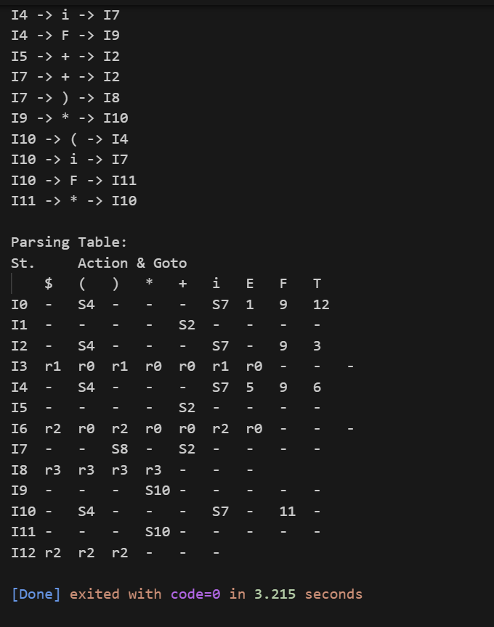**

**RESULT**

Thus to Implement lexical analyzer using C program has been executed and verified successfully.